**ASSIGNMENTS**

**1.**Try to achieve the below image on your own.



**CSS Colors used:**

**Background color**

#00000080

**Border color Hex Code value:**

#48ee59

**CSS Font families used:**

Bree Serif

2. LOGIN FORM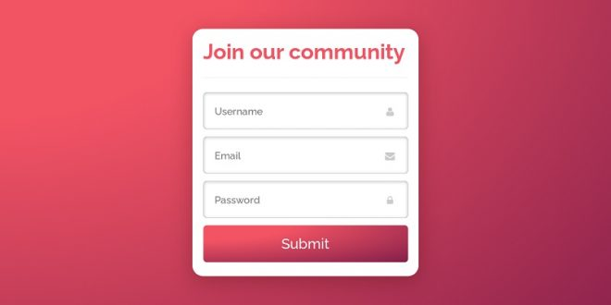

3. CONTACT US FORM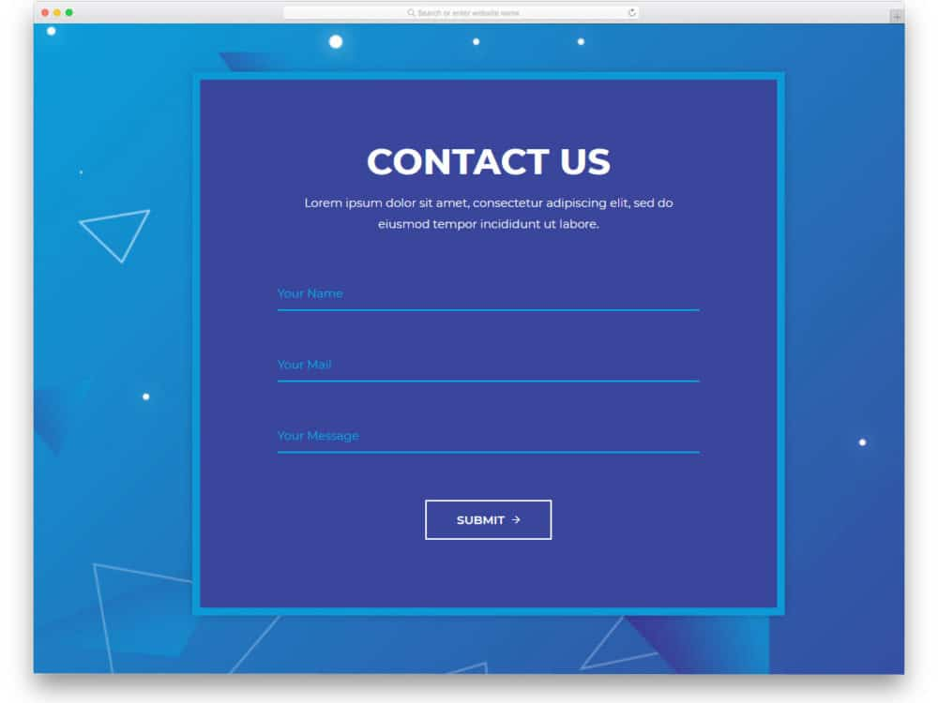

4. FACTS FORM

